Output for file: visualize_mnist.py

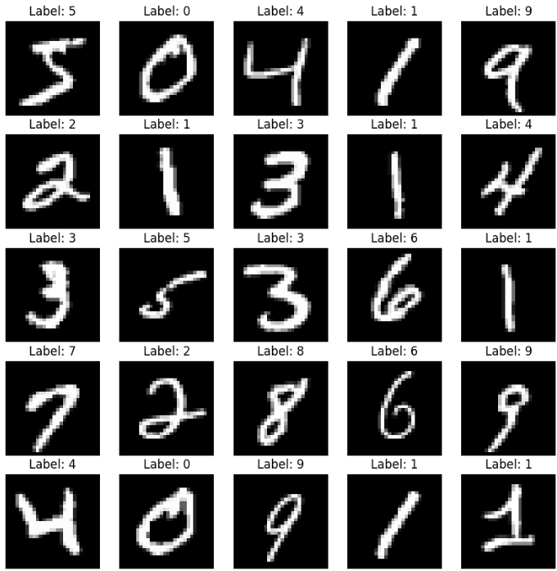

Output for file: visualize_cifar10.py

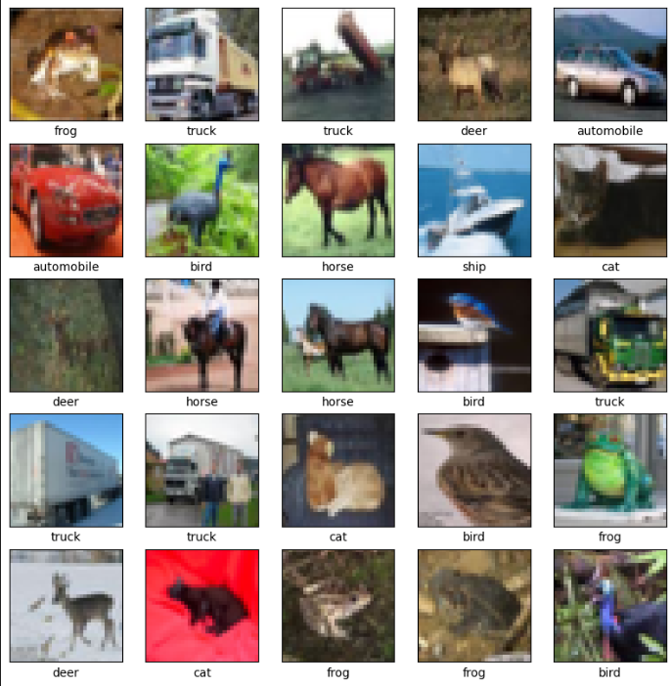

Output for file: visualize_imagenette.py

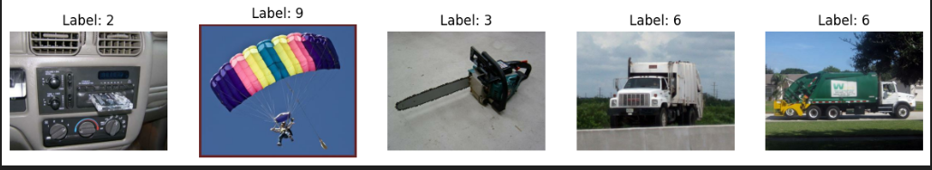

Output for file: mnist_vgg16_transfer_learning.py

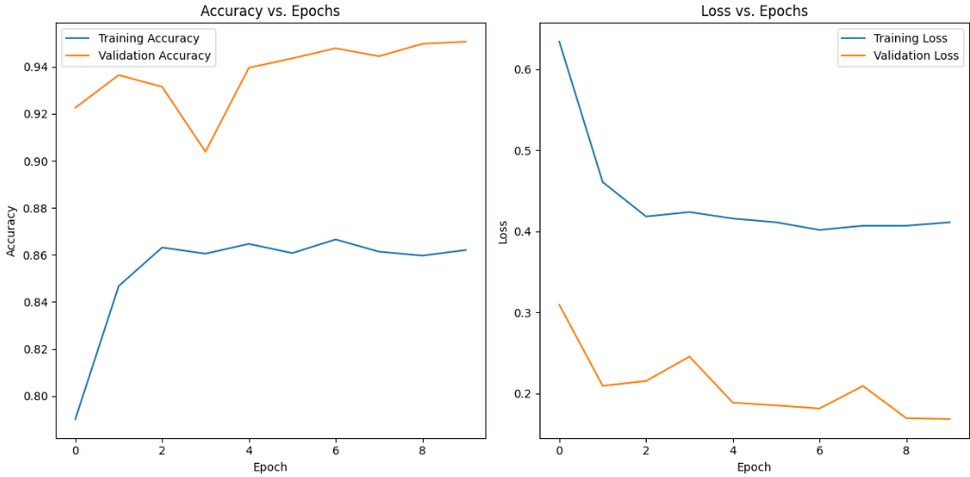

Output for file: cifar10_vgg16_transfer_learning.py

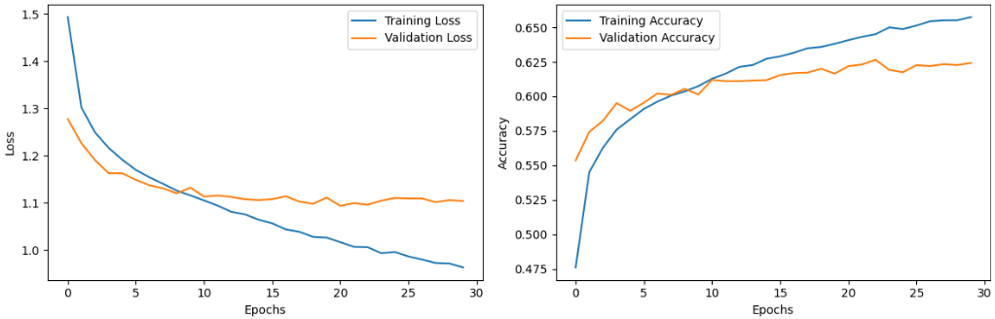

Output for file: mnist_vgg16_no_weights.py

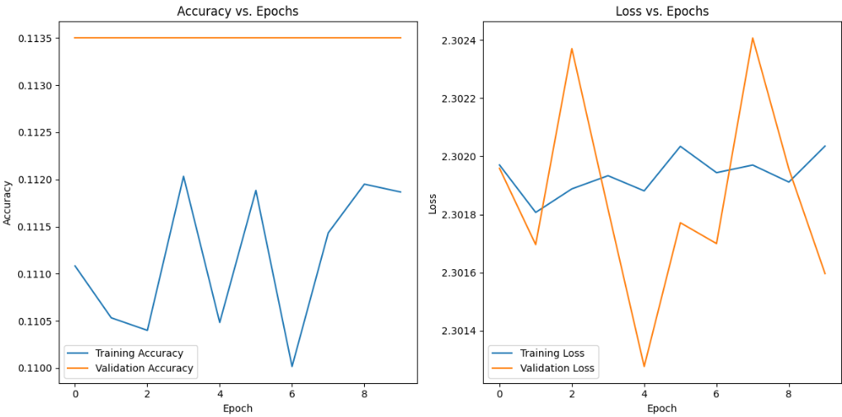

Output for file: cifar10_vgg16_no_weights.py

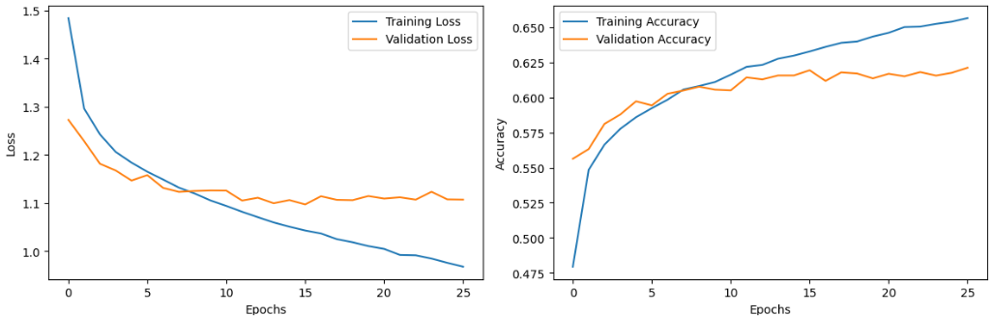

Output for file: cifar10_resnet50_transfer_learning.py

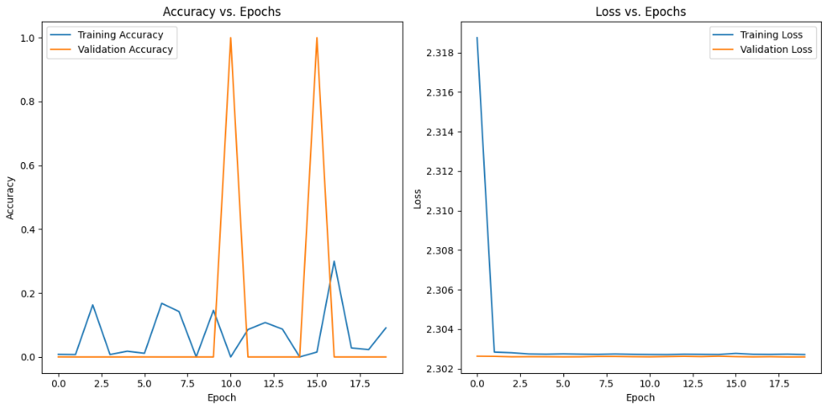

Output for file: imagenette_resnet50_transfer_learning.py

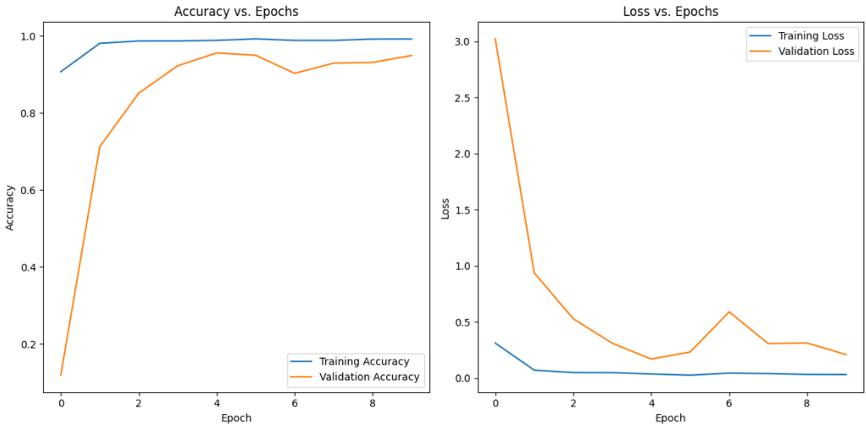

Output for file: cifar10_resnet50_no_weights.py

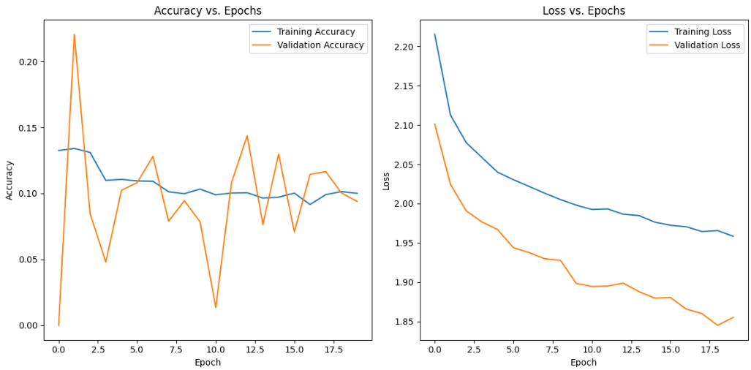

Output for file: imagenette_resnet50_no_weights.py

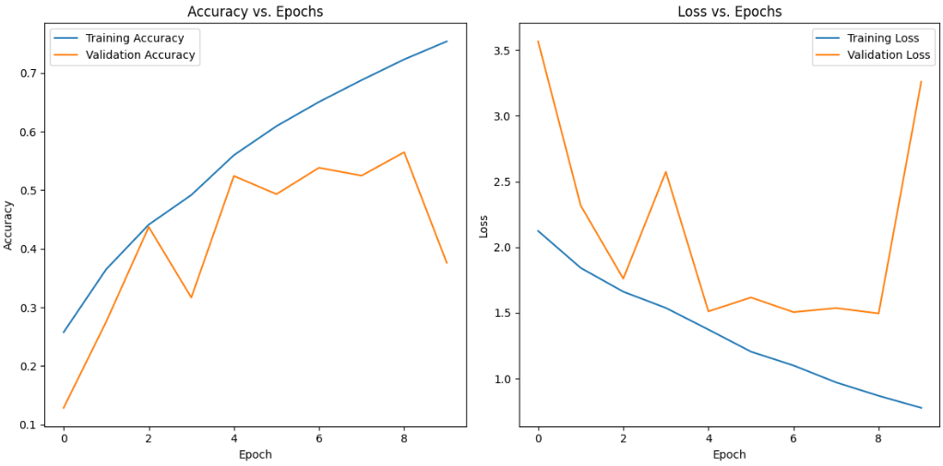

Output for file: imagenette_custom_cnn1.py

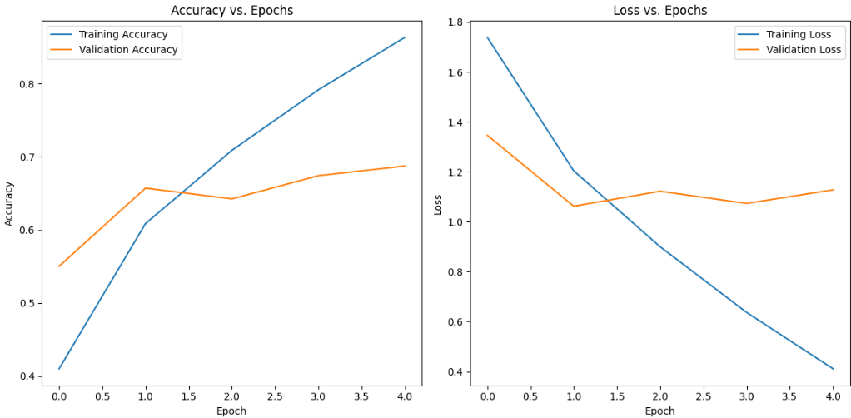

Output for file: mnist_custom_cnn1.py

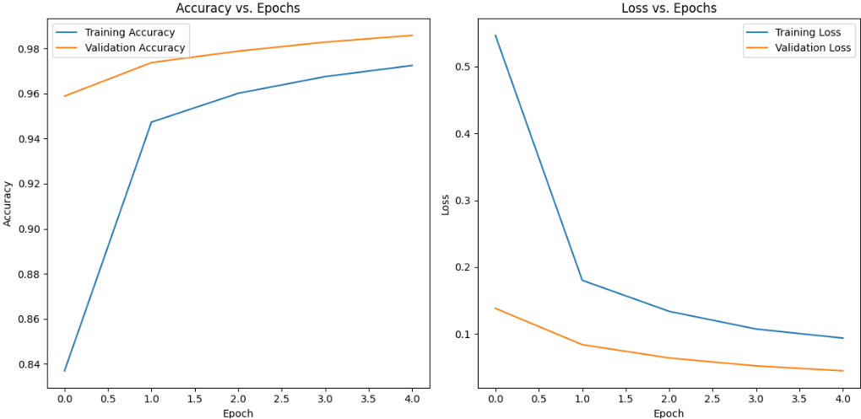

Output for file: cifar10_custom_cnn1.py

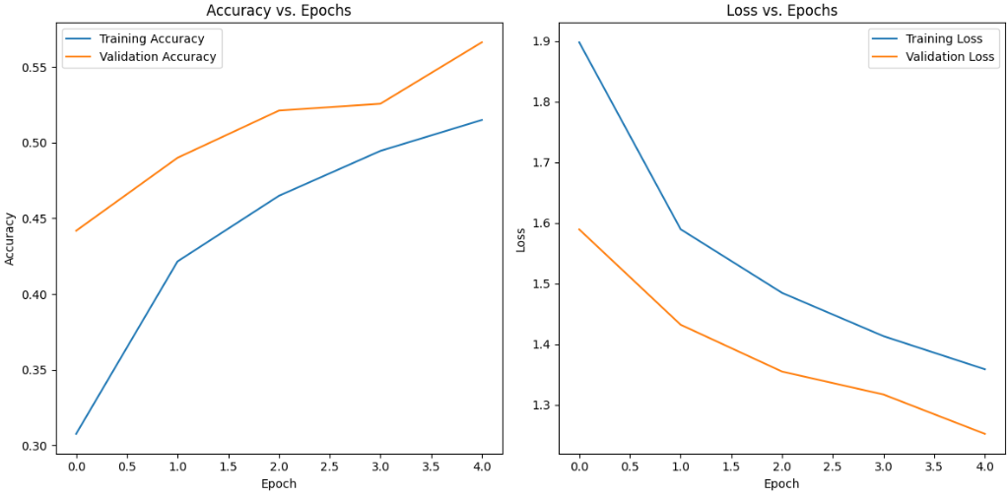

Output for file: mnist_custom_cnn2.py

